

Proctor Manual

July 18, 2018
Apr18,2017 (Updated website link locations, substitute all reference of 'student' to 'test taker')
Jul18,2018 Added Adobe Flash Player to proctor's checklist
(All recent changes are highlighted in yellow, except what is highlighted above in green: editor of other languages need to do such substitution in your respective document.)



2011-2018 IITTI
You can freely distribute this document.

Table of Contents
Table of Contents
Chapter 1 The IITTI Exam 3
What is the Exam like? 3
What does the Exam actually look like? 3
Chapter 2 Test Structure & Overview 5
How does it work? 5
Chapter 3 Your Job as a Proctor 6
What if test taker made a mistake or guessed in a written test? 6
What if a test taker did not finish the written test within the allotted time limit? 6
How are test takers' scores determined? 6
What if a test taker didn't answer the survey questions in the "Questionnaire" section? 6
Are all questions counted in a written test? 6
What computer skills do test takers need for the written test? 7
What test takers must have done before the actual exam day 7
Exam date and logistics 7
What test takers must bring 7
Help take greeting video of candidates 8
Exam password 8
When will test takers know their final scores? 9
More questions? 9
Appendix Proctor's Checklist 10

Chapter 1 The IITTI Exam

What is the Exam like?
There are three (3) levels of certification:

(1) Level 1, Basic
(2) Level 2, Standard
(3) Level 3, Advanced

We find it useful to describe each level with a single word or phrase; this allows everybody to describe very concisely what each level is about:

(1) Level 1, Basic – "keeping up"
(2) Level 2, Standard – "fluency"
(3) Level 3, Advanced – "refined"

Exam proctoring is required for the written parts of the exam for both Level 1 and Level 2. There is no written test for Level 3.

What does the Exam actually look like?
The computerized, written part of the Exam is web-based.

For example, Level 1 certification requires a computerized exam, and consists of four (4) separate sections in total of fill-in-the-blank and multiple-choice questions with their respective weights of:

1. Questionnaire 0%
2. Professional Appearance 30%
3. Business Etiquette 34%
4. Dining Etiquette 36%

The "Questionnaire" section is in a fill-in-the-blank format. It asks survey questions about whether the exam candidate had prior training, etc. Although the Questionnaire section carries zero weight, it is a compulsory section. The other three sections are in a multiple-choice format, asking technical questions in their respective subject matters.

Here is what the actual screen looks like:

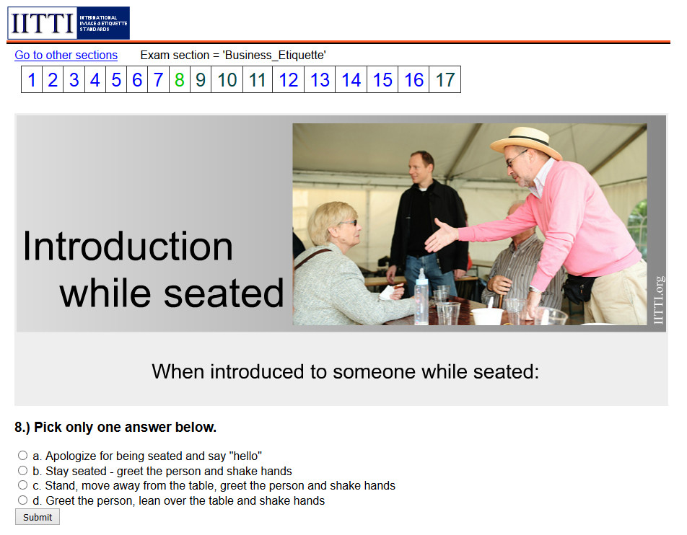

Chapter 2 Test Structure & Overview

Here is a quick snapshot of the different test for each level:

Level | Test Format | Timing | Location
1 | Written | 1 hour | Local
2 | Written and  Practicum | 1 hour written,  1.5 hour practicum | Local  Local
3 | Practicum | In-depth (over a few days) | Overseas

How does it work?

The written tests consist of web-based fill-in-the-blank and multiple-choice questions done locally at or near the city of the exam candidates. The questions are selected from a large pool of potential questions ranging across all the various topics of the IITTI guidelines such as professional appearance, business etiquette, dining etiquette, etc.

In most cases, you will be required to set up a set of pre-specified cameras at the exam venue to take video during the exam. This is for identifying exam candidates to prevent cheating.

To start the exam, each candidate will be asked to log on to their own accounts on the IITTI website. Proctors will be given an Exam ID and an Exam Password to give to the candidates in order for them to proceed. Once the exam time-frame is over, test takers are not allowed to continue with the exam; they must log off and immediately leave the exam room.

There are no exam papers collected afterward.

Chapter 3 Your Job as a Proctor

What if test taker made a mistake or guessed in a written test?

You should recommend candidates to go through the different sections in a sequential manner as presented. Once a multiple-choice question is answered, the computer system will score the question immediately, and the answer cannot be changed. The IITTI Exams are intend to test candidates on how well they know the materials, not on random guesses or marginal knowledge.

What if a test taker did not finish the written test within the allotted time limit?

Pacing is critical, as there is a heavy penalty for not completing. Exam candidates are strongly recommended to carry a watch and frequently checking to see the number of questions still unanswered. There are between 50-60 questions in each of the written exams in Level 1 and Level 2.

How are test takers' scores determined?

For a written test, the score is determined by:

- The number of questions they answered
- How many of the answered questions are correct

There is only a pass / fail score for a written test. The passing score is 75%. The practicum is also based on a pass / fail system. In the case of Level 2, a candidate only passes the whole test if both the written and practicum have been passed.

What if a test taker didn't answer the survey questions in the "Questionnaire" section?

If a test taker ignored the Questionnaire section, he/she will not be allowed to pass the exam.

Are all questions counted in a written test?

Every test contains trial multiple-choice questions being pretested for use in future tests. These questions are not identified, nor will they appear in different locations within the test. test takers should, therefore, do their best to answer all exam questions correctly. Answers to trial questions are not counted in the scoring of the test.

What computer skills do test takers need for the written test?

Test takers only need minimal computer skills to complete the written portion of an IITTI Exam. However, they should familiarize themselves with the mechanics of taking an online multiple-choice test such as the one available at http://www.iitti.org/selfTest/index.html.

What test takers must have done before the actual exam day

Each test taker should have registered and paid the exam fees to their respective college, university, or etiquette school prior to the scheduled exam day. After registration the participants will be given an IITTI exam user pass by their schools.

The exam user pass is like a phone card. Once test takers receive their exam passes, they should enter the exam user code into their personal accounts on the IITTI website. A test taker won't be able to access any exam without entering the exam code into his/her account.

Test takers should be strongly advised to enter their exam pass into the account before the exam day.

Exam date and logistics

Test takers' schools will coordinate with IITTI as well as your testing centre to arrange for a suitable date for the test. The schools will provide a list of exam candidates to IITTI and, in turn, IITTI will provide the proctor with this list of names.

The exam venue must have computers capable of accessing the internet with a browser such as Microsoft Internet Explorer, Mozilla Firefox, or Google Chrome. (The standardized browser for the IITTI Exam is the Mozilla Firefox Browser.)

Test takers should not be allowed to bring in any books, leaflets, or their laptops, tablets, smart phones, or any other devices capable of accessing the internet.

What test takers must bring

Every test taker needs to bring valid identification such as a driver's license, birth certificate, or passport. The name on his/her identification document must be the same as the name on the list of names provided to you, otherwise refuse his/her entrance into the exam room until he/she has corrected the situation.

Test takers should remember their IITTI user account ID and user password for the exam.
They should have entered their exam user codes beforehand. Proctors should strongly encourage test takers to carry a watch for time-keeping.

Help take greeting video of candidates

If video cameras are instructed by IITTI to be set up in the exam room, you would need to help exam candidates in taking their video for identification purpose. Help candidates stand close to one of the cameras, ask them to smile, and instruct them to announce themselves as follow:

"Hi, my name is ___________. I am from (his/her city and country). And I am
here to write the ET exam."

Make sure their faces are visible to the camera without any hat or hair covering their faces. Ask them to take off their sunglasses. Disqualify any candidate who has heavy makeup in such a way that will distort their facial features. Ask candidates to speak clearly and loudly so that the video can pick up their voices. Warn candidates that their exam will be voided if IITTI finds their identities to be in doubt or unclear.

Exam password

Each written test has a unique exam ID and password. On the day of the exam, as a proctor, you will need to contact IITTI to get this password. You can contact IITTI either by phone (1.604.231.8197) or email (info@IITTI.org). IITTI will tell you the exact exam ID and its associated password. Example of exam ID and exam password is:

Exam ID = "ExamBasicSP_lima"
Exam password = "happy"

After you have the exam ID and exam password, ask test takers to log on to their IITTI account under 'Test Takers', go to:

Exam area > Add exam

in order to select the exam ID and enter the exam password.

Proctors should not tell anyone about this exam ID or password until the exam start time. Only participants in the exam room should be given these ID and password.

When will test takers know their final scores?

Exam candidates can see their "raw score" immediately, but will not be able to see their final ("adjusted") scores immediately. This is because certain questions are trial questions and may not be counted towards the adjusted, final score. The final percentage won't be shown until 1-2 weeks later.

More questions?

Check out our online link at: www.IITTI.org/proctors/proctorArea_en.htm

Appendix Proctor's Checklist
Double-check exam room beforehand:
  - Make sure there are enough computers for every test taker.
  - Make sure all computers can access the internet and have a working browser. (The standardized browser for the IITTI Exam is the Mozilla Firefox Browser, with Adobe Flash Player.)
  - Make sure all browsers are allowed to accept cookies.
  - Make sure the Internet Service Provider (ISP) of the exam venue does not cut out cookies.
  - Make sure all video cameras have been set up (if instructed to do so) and turned on for recording.

Prepare test takers before entering the exam room:
  - Confirm with test takers they have entered their user pass codes into their accounts.
  - Remind test takers to remember their IITTI account ID and password.
  - Inspect valid personal identification against the list of names.
  - Encourage test takers to bring a watch into the exam room. (Exam is one hour.)

Right before the exam:
  - Help line up all candidates in taking their greeting video for identification purpose.

At beginning of the exam:
  - Inspect all candidates to make sure they have not bring in any books, leaflets, or internet-accessible devices such as laptop, smart phones, etc.
  - Contact IITTI to get the exam ID and password.
  - Disclose exam ID and password to all candidates.

During the exam:
  - Candidates are not to consult one another at any time.
  - No late candidates are allowed into the exam room 15 minutes after the start of the test.
  - Remind candidates of the time remaining at the 30-minute, 15-minute and 5-minute mark.
  - If part of the screen doesn't display properly due to a slow internet, ask candidate to click on 'reload' button in the browser to refresh the screen.
  - Take video of the entire exam session as one video file without breaks.

After the exam:
  - The exam must be stopped one (1) hour after the beginning.
  - All candidates must log off their accounts and leave the exam room.
  - Send the cameras' SD cards to IITTI headquarters in Vancouver, Canada, or upload the video files to an IITTI-specified "DropBox" style file-sharing service. Details of video file names and all at www.IITTI.org/proctors/proctorArea_en.htm.

Contact IITTI at:

International Soft Skills Standards & Testing (IITTI)
Vancouver, Canada
Tel: (604) 231-8197
web: www.IITTI.org
email: info@IITTI.org

2011-2018 IITTI.
You can freely distribute this document.

