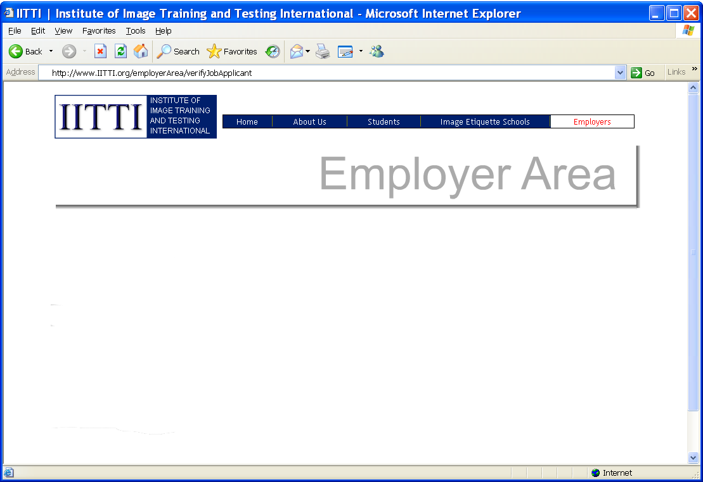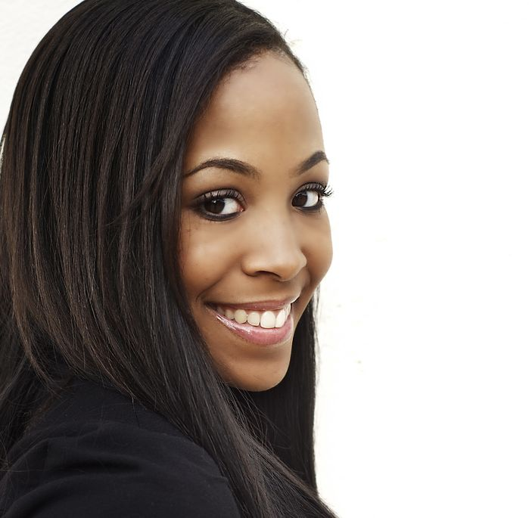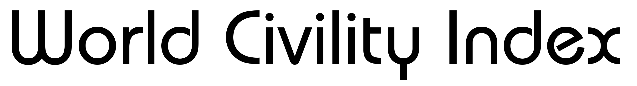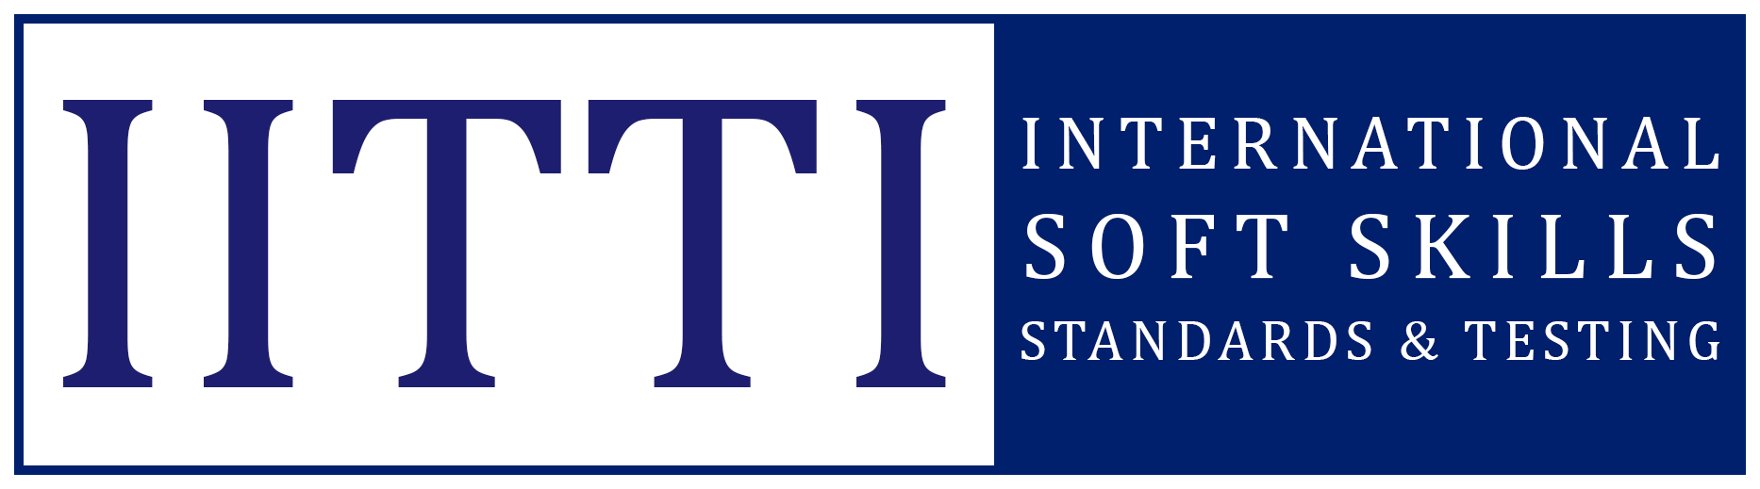

**_________________________________________________________________________________**

**Looking for a job?**

**Get an Edge with the World Civility Index Credential**

**World Civility Index**

Joyce Hilton

**HR can independently verify your**

**soft skills using the IITTI website**

**Want a good job? Promotion?**

**Understanding bosses' concern**

**Job market needs verification tool**

Knowing your stuff is, of course, important. But it is not enough.

The secret to success lies in your ability to relate to others, and your image in terms of your appearance, behaviour and communication.

You need to understand that no boss wants an employee with an image that ruins the reputation of the company. No matter how well you can do the job, image makes or breaks your job opportunities.

Without exception, all Fortune 500 CEOs agree, the biggest challenge that they face is their ability to select and hire the best talents. The higher the position, the more it is not just about the hard skills of a candidate, but “soft skills” such as etiquette, professional image, and ethics.

How can you show hiring employers that you have these soft skills?

According to surveys, human resources (HR) departments seek global standards for soft skills such as business etiquette, empathy, and intercultural awareness. And the World Civility Index offers just such a structure that job-seekers can use, and HRs can easily verify.

You can start to earn World Civility Index “points” by reading an article or watch a video everyday:

**______________________________________________________________________________**

helps job-seekers in verifying their soft skills credentials to employers.

© 2011-2022 International Soft Skills Standards & Testing (IITTI)

Name:

www.IITTI.org/Read

Just like your personal credit rating, the World Civility Index would be the equivalent rating for your soft skills.

***"How will I know she'll be the best fit for the job?"***

**Employer's thought:**

July 13, 2022

**122**

*Powered by:*